CS5590 – Big Data Analytics

Lab3 Report

Submitted by Giresh

Created an android application with buttons to represent the CRUD procedures of Hbase data transfer.

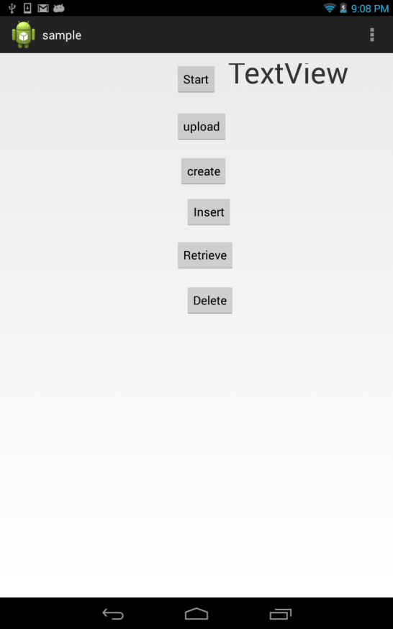

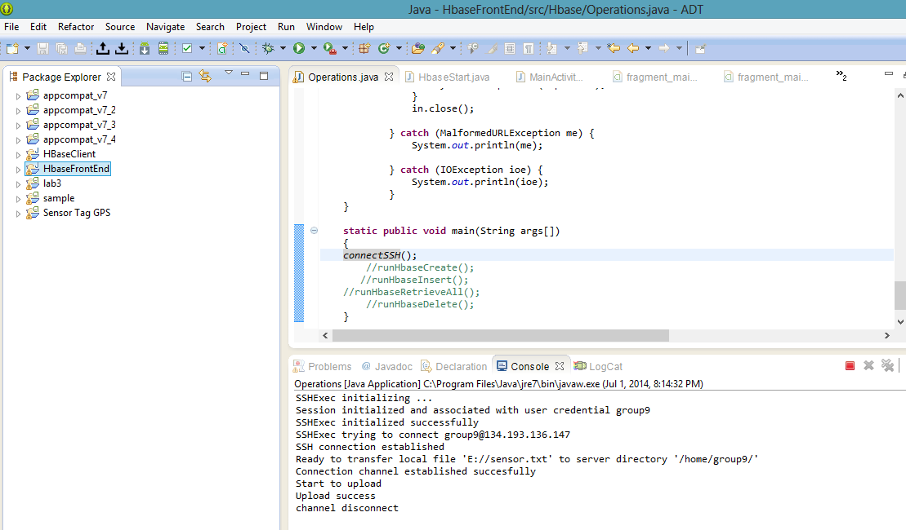The text file is uploaded to the remote Cloudera

The table is successfully created over hbase

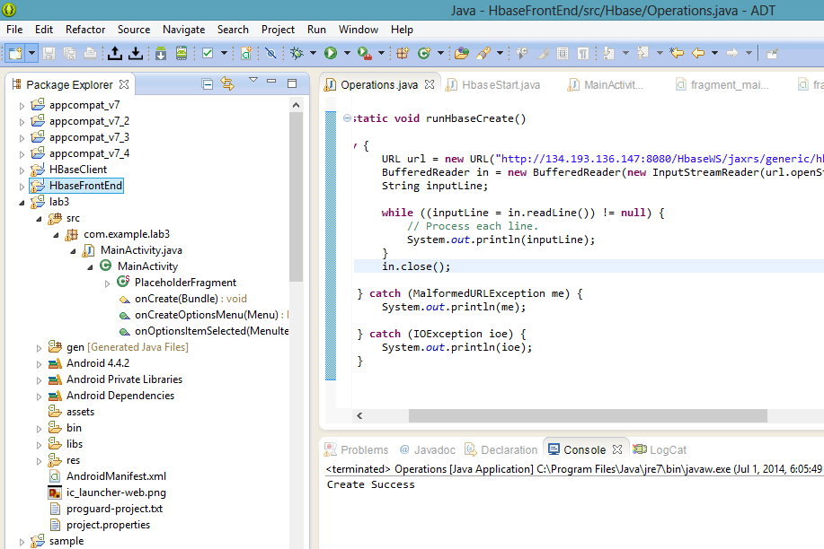

Hbase web ui that shows the table with column families

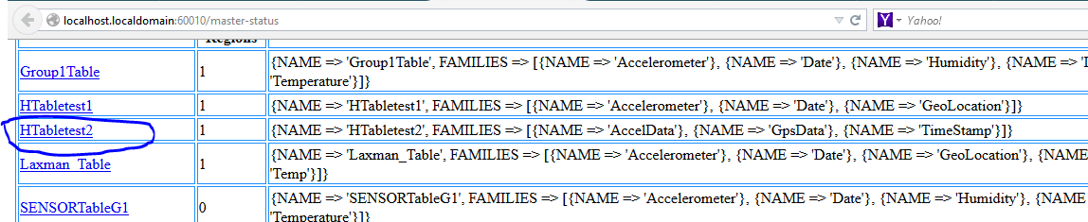

Permission denied result on the event of insertion of data to Cloudera is observed

And successful deletion of the table from cloud era

